**Exception handling best practices in C#**

Writing software is a complex task, and it's quite common to see applications crash due to bad code, bad user input, unavailable resources or unexpected conditions at runtime, and so on. And when this happens, we say an exception has occurred that caused the app to crash.

*An exception is a runtime error in a program that violates a system or application constraint, or a condition that is not expected to occur during the normal execution of the program.*

A well-designed app must handle exceptions and prevent the app from crashing. This article describes some of the best practices to follow while handling exceptions in C#.

1. Use throw instead of throw ex.
2. Log the exception object while logging exceptions.
3. Avoid catch block that just rethrows it.
4. Do not swallow the exception.
5. Throw exceptions instead of returning an error code.
6. Common failure conditions should be handled without throwing exceptions.
7. Use grammatically correct and meaningful error messages.
8. ApplicationException should never be thrown from code.
9. Use the predefined exception types.
10. End custom exception class names with the word Exception.

**1. Use**throw**instead of**throw ex

Using throw ex inside a catch block *does not preserve* the stack trace and the original offender would be lost. Instead use throw as it preserves the stack track and the original offender would be available.

// Bad code

catch(Exception ex)

{

throw ex; // Stack trace will show this line as the original offender.

}

// Good code

catch(Exception ex)

{

throw; // The original offender would be rightly pointed.

}

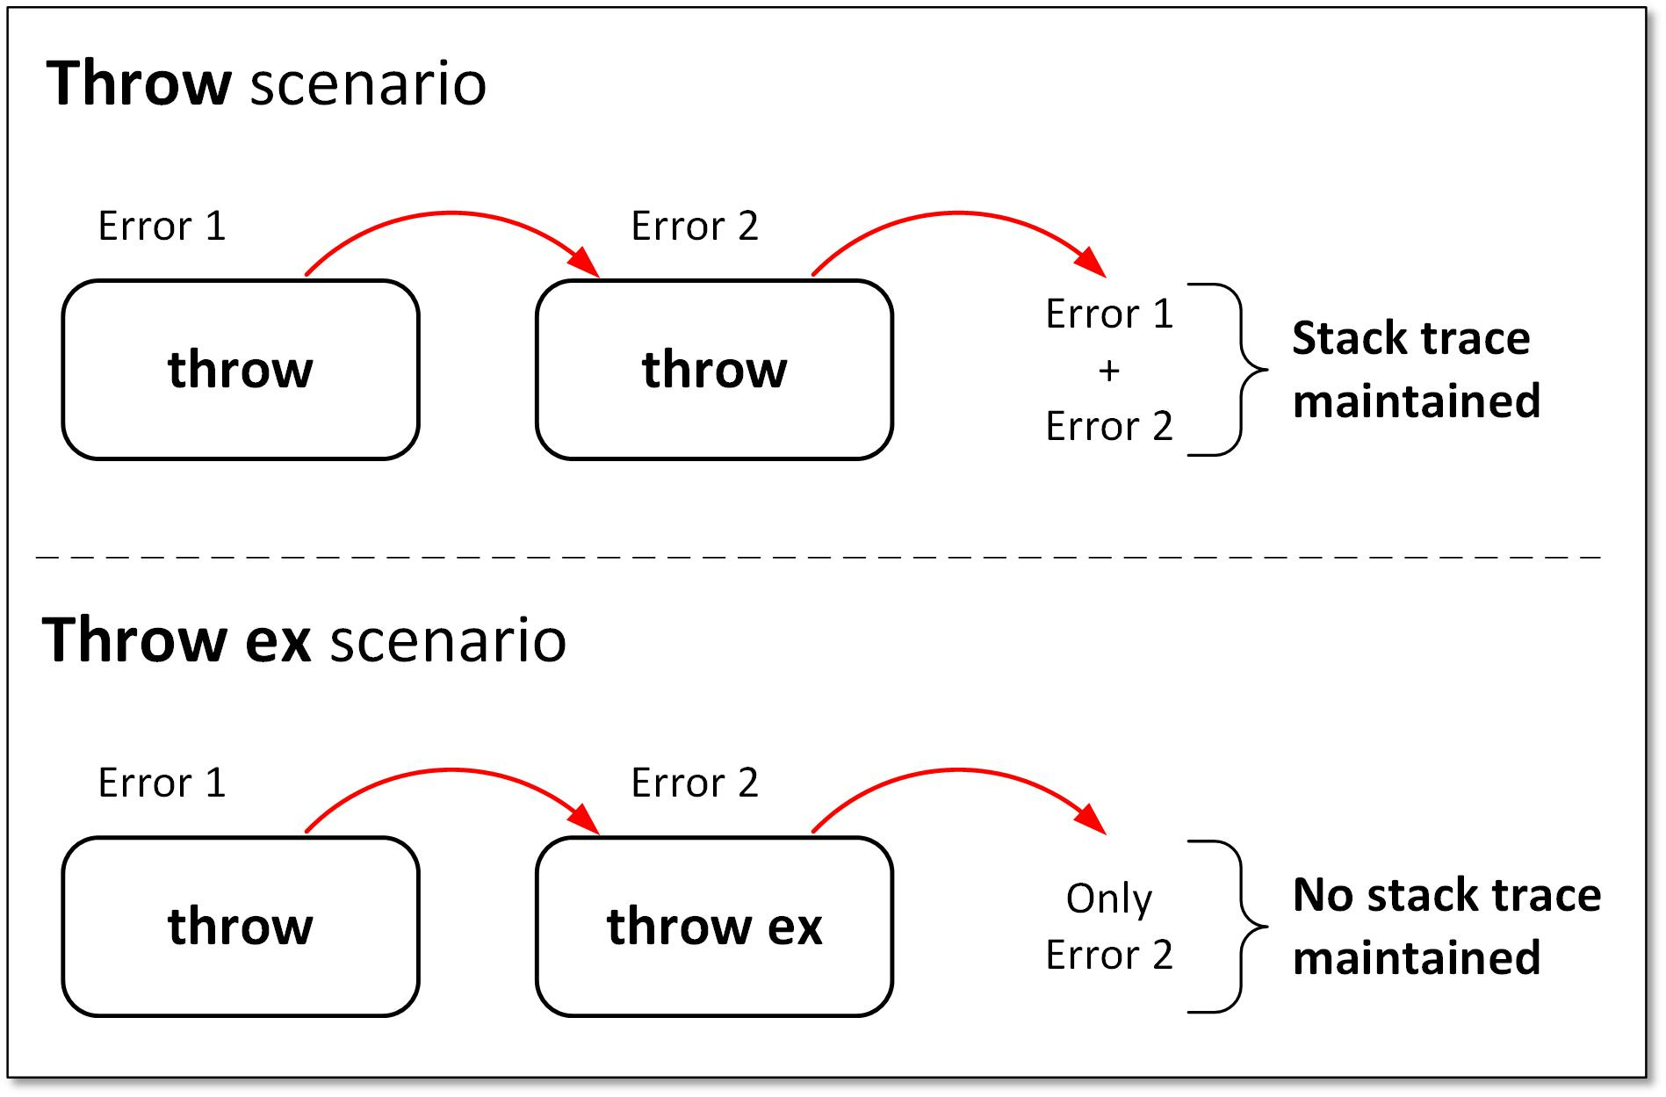

Read more about this on my blog - [Exception handling in C# - throw or throw ex](https://kumarashwinhubert.com/exception-handling-in-csharp-throw-or-throw-ex)

**2. Log the exception object while logging exceptions**

Often developers log just the exception message to the logging system without the exception object. The exception object contains crucial information such as exception type, stack trace, etc. and it's very important to log it.

If you are using the ILogger, there are extension methods to LogError, LogCritical, Log, etc that accepts exception object as a parameter; use those instead of just the message ones.  
LogCritical(Exception exception, string message, params object[] args)  
LogError(Exception exception, string message, params object[] args)  
Log(LogLevel logLevel, Exception exception, string message, params object[] args)

// Bad code

catch (DivideByZeroException ex)

{

// The exception object ex is not logged, thus crucial info is lost

this.logger.LogError("Divide By Zero Exception occurred");

}

In the above example, the exception object ex is not logged resulting in loss of stack trace.

// Good code

catch (DivideByZeroException ex)

{

this.logger.LogError(ex, "Divide By Zero Exception occurred");

}

**3. Avoid catch block that just rethrows it**

Don't simply catch an exception and just re-throw it. If the catch block has no other purpose, remove the try-catch block and let the calling function catch the exception and do something with it.

// Bad code

public void Method1() {

try {

Method2();

}

catch (Exception ex) {

// Code to handle the exception

// Log the exception

this.logger.LogError(ex);

throw;

}

}

public void Method2() {

try {

// Code that will throw exception

}

catch (Exception) {

throw;

}

}

In the above example, Method1 is calling Method2 and there is a possibility of an exception occurring in Method2. The catch block in Method2 does nothing with the exception and just re-throws it.  
Instead, the try-catch block in Method2 can be removed and the caller which is Method1 in this case can catch the exception and handle it.

// Good code

public void Method1()

{

try {

Method2();

}

catch (Exception ex) {

// Code to handle the exception

// Log the exception

this.logger.LogError(ex);

throw;

}

}

public void Method2()

{

// Code that will throw exception

// No try-catch block here as this method doesn't know how to handle the exception

}

**4. Do not swallow the exception**

One of the worst things to do in exception handling is swallowing the exception without doing anything. If the exception is swallowed without even logging there won't be any trace of the issue that occurred. If you are not sure of what to do with the exception, don't catch it or at least re-throw it.

// Bad code

try

{

// Code that will throw exception

}

catch (Exception ex)

{

}

**5. Throw exceptions instead of returning an error code**

Sometimes instead of throwing exceptions developers return error codes to the calling function, this might lead to exceptions going unnoticed as the calling functions might not always check for the return code.

// Bad code

public int Method2()

{

try

{

// Code that might throw exception

}

catch (Exception)

{

LogError(ex);

// This is bad approach as the caller function

// might miss to check the error code.

return -1;

}

}

**6. Common failure conditions should be handled without throwing exceptions**

For conditions that are likely to occur and trigger an exception, consider handling them in a way that will avoid the exception. Example -

* Close the connection only after checking if it's not already closed.
* Before opening a file, check if it exists using the File.Exists(path) method.
* Use fail-safe methods like - CreateTableIfNotExists while dealing with databases and tables.
* Before dividing, ensure the divisor is not 0.
* Check null before assigning value inside a null object.
* While dealing with parsing, consider using the TryParse methods.

// Bad code

int.Parse(input);

// Good code

int.TryParse(input, out int output);

**7. Use grammatically correct and meaningful error messages**

Ensure that the error messages are clear and **end with a period**. The exception message should not be abrupt and open-ended. Clear and meaningful messages give the developer a good idea of what the issue could have been while trying to replicate and fix the issue.

// Bad code

catch (FileNotFoundException ex)

{

this.logger.LogError(ex, "Something went wrong");

}

// Good code

catch (FileNotFoundException ex)

{

this.logger.LogError(ex, "Could not find the requested file.");

}

**8.**ApplicationException**should never be thrown from code**

In the initial design of .NET, it was planned that the framework will throw SystemException while user applications will throw ApplicationException. However, a lot of exception classes didn't follow this pattern and the ApplicationException class lost all the meaning, and in practice, this found to add no significant value.

Hence it's advised that you should not throw an ApplicationException from your code and you should not catch an ApplicationException too unless you intend to re-throw the original exception. Also custom exceptions **should not be derived** from ApplicationException.

**9. Use the predefined exception types**

There are many exceptions already predefined in .NET. Some of them being:

* DivideByZeroException is thrown if the divisor is 0.
* ArgumentException, ArgumentNullException, or ArgumentOutOfRangeException is thrown if invalid parameters are passed.
* InvalidOperationException is thrown if a method call or property set is not appropriate in the object's current state.
* FileNotFoundException is thrown if the file is not present.
* IndexOutOfRangeException is thrown if the item being accessed from an array/collection is outside its bounds.

The predefined exceptions are sufficient in most of the cases. Hence introduce a new custom exception class only when a predefined one doesn't apply or you would like to have some additional business analytics based on some custom exception, e.g. A custom exception - TransferFundsException can be used to keep track of fund transfer exceptions and generate business analytics & insights from it.

**10. End custom exception class names with the word**Exception

As mentioned earlier, the predefined exception types are sufficient in most of the cases, but when a custom exception is necessary, name it appropriately and end the exception name with the word "Exception".

Also, ensure that the custom exception derives from the Exception class and **includes at least the three common constructors** :

* Parameterless constructor
* Constructor that takes a string message
* Constructor that takes a string message and an inner exception

Example:

using System;

public class TransferFundsException : Exception

{

public TransferFundsException()

{

}

public TransferFundsException(string message)

: base(message)

{

}

public TransferFundsException(string message, Exception inner)

: base(message, inner)

{

}

}

**Final Thoughts**

These are some of the exception handling practices that I use and find very helpful in my day-to-day work. Some of the above ones might look obvious, but often go unnoticed by many. Let me know your thoughts and do mention any other exception handling practices that you follow.